Project Design Phase-II
Data Flow Diagram & User Stories

Date | 05 july 2026
Project Name | Cab booking
Maximum Marks | 4 Marks

Data Flow Diagrams:
A Data Flow Diagram (DFD) is a traditional visual representation of the information flows within a system. A neat and clear DFD can depict the right amount of the system requirement graphically. It shows how data enters and leaves the system, what changes the information, and where data is stored.

Data flow diagram-
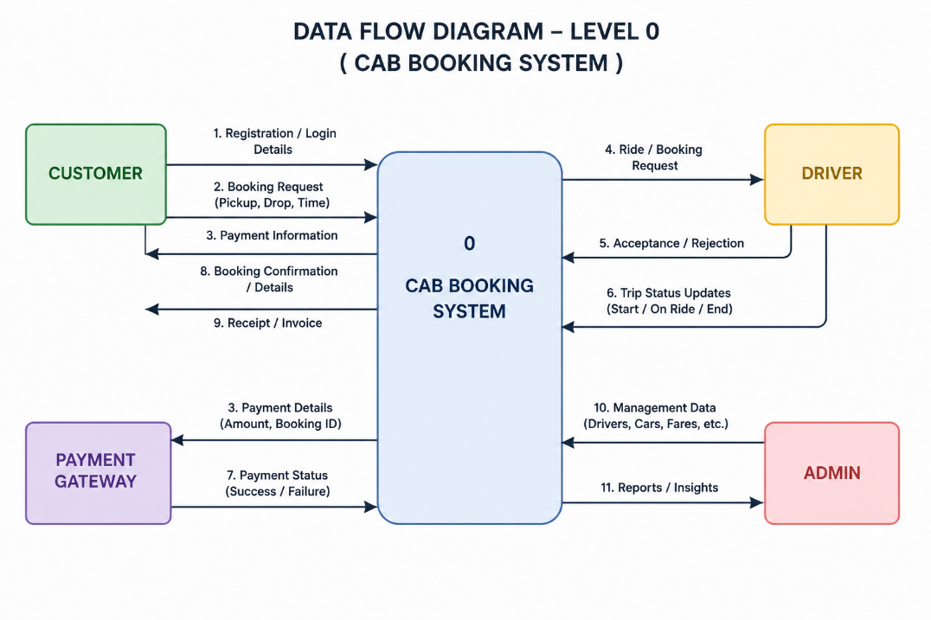
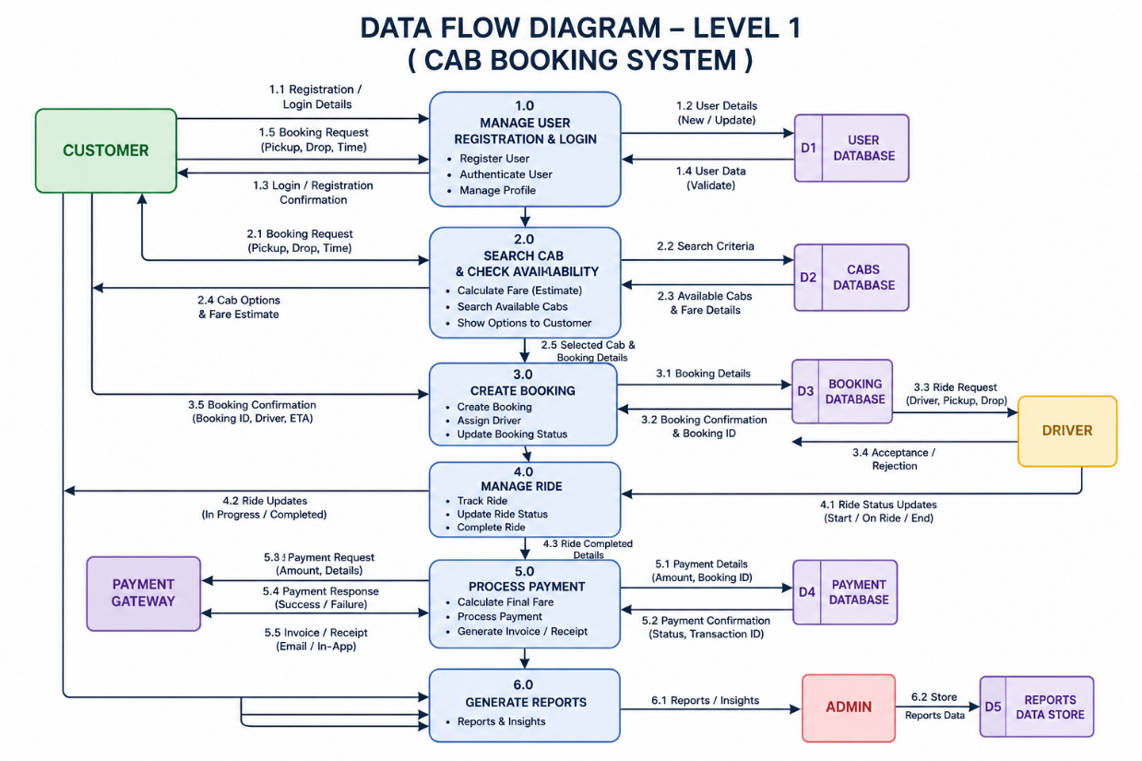

User Stories
User Type | Functional Requirement (Epic) | User Story No. | User Story / Task | Acceptance Criteria | Priority | Release
Customer | Registration | USN-1 | As a user, I can register using my name, email, phone number, and password. | User account is created successfully. | High | Sprint-1
Customer | Login | USN-2 | As a user, I can log in using my email and password. | User can access the dashboard. | High | Sprint-1
Customer | Cab Booking | USN-3 | As a user, I can book a cab by selecting pickup and drop locations. | Booking is confirmed successfully. | High | Sprint-2
Customer | Fare Estimation | USN-4 | As a user, I can view the estimated fare before booking. | Correct fare is displayed. | Medium | Sprint-2
Customer | Ride Tracking | USN-5 | As a user, I can track my ride in real time. | Live ride status is displayed. | High | Sprint-3
Customer | Payment | USN-6 | As a user, I can make online payments securely. | Payment is completed successfully. | High | Sprint-3
Driver | Driver Registration | USN-7 | As a driver, I can register my vehicle and profile. | Driver account is created successfully. | High | Sprint-1
Driver | Ride Management | USN-8 | As a driver, I can accept or reject ride requests. | Ride status is updated correctly. | High | Sprint-3
Administrator | Dashboard | USN-9 | As an admin, I can manage users, drivers, bookings, and payments. | Admin dashboard displays all records. | High | Sprint-4

